Ideation Phase

Define the Problem Statements

|  |  |
| --- | --- |
| Team ID | PNT2022TMID10050 |
| Project Name | Personal Assistant for seniors who are self- reliant |
| Maximum Marks | 2 Marks |

**Customer Problem Statement:**

It is very difficult for the senior citizens (elder people) to remember their medicines. To avoid the skipping up the medicines,they can be remembered by using the voice commands of the medicine names at correct time specified. If the voice commands on the medicine name is not available, they are given the reminder of the medicine by SMS on their phone or to their closest person.

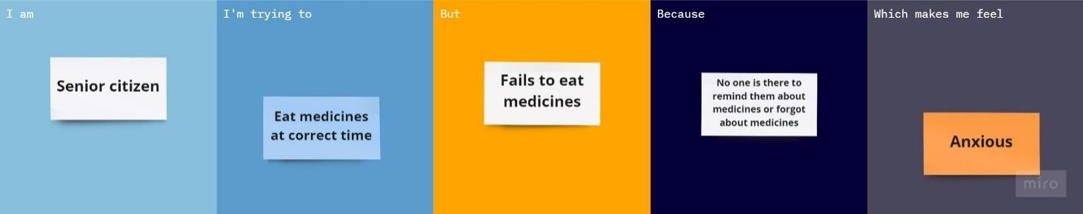

Reference: [https://miro.com/app/board/uXjVPNRNvzg=/?share_link_id=213829070965](https://miro.com/app/board/uXjVPNRNvzg%3D/?share_link_id=213829070965)

|  |  |  |  |  |  |
| --- | --- | --- | --- | --- | --- |
| **Problem Statement (PS)** | **I am (Customer)** | **I’m trying to** | **But** | **Because** | **Which makes me feel** |
| PS-1 | Senior citizen who is self- reliant. | Eat medicines at correct time | Fails to eat | No one is there to remind about medicines or forgot by  themselves | anxious |